**Fetch Rewards-Analytical Engineer Internship**

# **First: Review Existing Unstructured Data and Diagram a New Structured Relational Data Model**

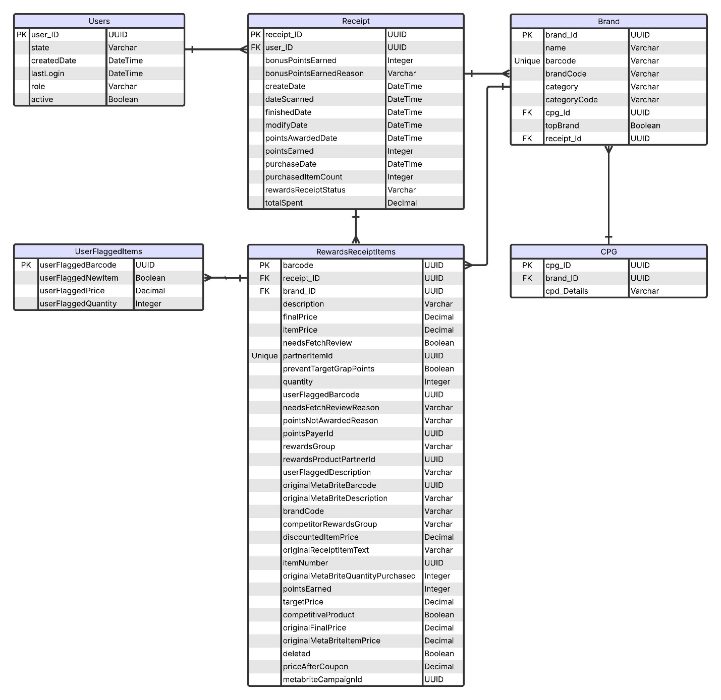

# **Second: Write queries that directly answer predetermined questions from a business stakeholder**

1. What are the top 5 brands by receipts scanned for most recent month?

SELECT b.name, COUNT(DISTINCT r.receipt_id) AS receipt_count

FROM Brand b

JOIN RewardsReceiptItems rri ON b.brand_id = rri.brand_id

JOIN Receipts r ON rri.receipt_id = r.receipt_id

WHERE strftime('%Y-%m', r.dateScanned) = (

SELECT strftime('%Y-%m', MAX(dateScanned))

FROM Receipts)

GROUP BY b.name

ORDER BY receipt_count DESC

LIMIT 5;

1. How does the ranking of the top 5 brands by receipts scanned for the recent month compare to the ranking for the previous month?

SELECT b.name, COUNT(DISTINCT r.receipt_id) AS receipt_count

FROM Brand b

JOIN RewardsReceiptItems rri ON b.brand_id = rri.brand_id

JOIN Receipts r ON rri.receipt_id = r.receipt_id

WHERE strftime('%Y-%m', r.dateScanned) = (

SELECT strftime('%Y-%m', date(MAX(dateScanned), '-1 month'))

FROM Receipts)

GROUP BY b.name

ORDER BY receipt_count DESC

LIMIT 5;

1. How does the ranking of the top 5 brands by receipts scanned for the recent month compare to the ranking for the previous month?

SELECT rewardsReceiptStatus, AVG(totalSpent) AS average_spend

FROM Receipts

WHERE RewardsReceiptStatus IN ('FINISHED', 'REJECTED')

GROUP BY rewardsReceiptStatus;

1. How does the ranking of the top 5 brands by receipts scanned for the recent month compare to the ranking for the previous month?

SELECT rewardsReceiptStatus, SUM(purchasedItemCount) AS total_items_purchased

FROM Receipts

WHERE rewardsReceiptStatus IN ('FINISHED', 'REJECTED')

GROUP BY rewardsReceiptStatus;

1. How does the ranking of the top 5 brands by receipts scanned for the recent month compare to the ranking for the previous month?

SELECT b.name, SUM(r.totalSpent) AS total_spend

FROM Brand b

JOIN RewardsReceiptItems rri ON b.brand_id = rri.brand_id

JOIN Receipts r ON rri.receipt_id = r.receipt_id

WHERE r.createDate >= date('now', '-6 months')

GROUP BY b.name

ORDER BY total_spend DESC

LIMIT 1;

1. How does the ranking of the top 5 brands by receipts scanned for the recent month compare to the ranking for the previous month?

SELECT b.name, COUNT(DISTINCT r.receipt_id) AS transaction_count

FROM Brand b

JOIN RewardsReceiptItems rri ON b.brand_id = rri.brand_id

JOIN Receipts r ON rri.receipt_id = r.receipt_id

WHERE r.createDate >= date('now', '-6 months')

GROUP BY b.name

ORDER BY transaction_count DESC

LIMIT 1;

# **Third: Evaluate Data Quality Issues in the Data Provided**